SMART STREET LIGHT SYSTEM USING PIR AND LDR SENSORS

A MINI PROJECT REPORT

Submitted by

KASTHURI N 2303921310522030
BHUVANA P 2303921310522012
HEMALATHA B 2303921310522025

in partial fulfillment for the award of the ESIOT laboratory
of

BACHELOR OF ENGINEERING
in
ELECTRICAL AND ELECTRONICS ENGINEERING
PSNA COLLEGE OF ENGINEERING AND TECHNOLOGY

MAY 2026

BONAFIDE CERTIFICATE

Certified that this mini project report "SMART STREET LIGHT SYSTEM USING PIR AND LDR SENSORS" is the bonafide work of "KASTHURI N, BHUVANA P, HEMALATHA B" who carried out the project work under my supervision.

SIGNATURE
SUPERVISOR

ABSTRACT

This project presents the design and implementation of a Smart Street Light System using PIR (Passive Infrared) and LDR (Light Dependent Resistor) sensors interfaced with an Arduino Uno microcontroller. The system aims to reduce energy consumption in street lighting by automatically controlling the brightness of LEDs based on ambient light conditions and human motion detection.
The LDR sensor continuously monitors the surrounding light intensity. During daytime, when sufficient natural light is available, the street light remains switched off. During nighttime, the system activates and the PIR sensor monitors the area for motion. When motion is detected, the LED glows at full brightness (255 PWM). In the absence of motion, the LED operates at dim brightness (80 PWM) to save energy while maintaining minimal illumination.
The system is simulated using Tinkercad, a web-based circuit simulation platform. The Arduino Uno is programmed using embedded C within the Arduino IDE. The project demonstrates a cost-effective, energy-efficient, and automated approach to modern street lighting, which has practical applications in smart city infrastructure.

TABLE OF CONTENTS
CHAPTER NO. | TITLE | PAGE NO.
 | ABSTRACT | 3
 | LIST OF FIGURES | 5
 | LIST OF TABLES | 5
 | LIST OF SYMBOLS | 6
1 | INTRODUCTION | 7
2 | LITERATURE REVIEW | 9
3 | SYSTEM DESIGN AND METHODOLOGY | 11
4 | COMPONENTS DESCRIPTION | 16
5 | SOFTWARE IMPLEMENTATION | 18
6 | HARDWARE IMPLEMENTATION | 19
6 | RESULTS AND DISCUSSION | 20
7 | CONCLUSION AND FUTURE SCOPE | 22
8 | APPENDICES | 23
9 | REFERENCE | 25

LIST OF TABLES
Table No. | Title | Page No.
Table 4.1 | List of Components | 15
Table 6.1 | Simulation Results | 20
Figure No. | Title | Page No.
Figure 3.1 | Block Diagram of Smart Street Light System | 10
Figure 5.3 | TinkerCad Simulation | 18
Figure 5.4 | Circuit Connection, Hardware Output | 19

LIST OF FIGURES

LIST OF SYMBOLS, ABBREVIATIONS AND NOMENCLATURE
Abbreviation | Meaning
PIR | Passive Infrared Sensor
LDR | Light Dependent Resistor
PWM | Pulse Width Modulation
LED | Light Emitting Diode
IDE | Integrated Development Environment
GSM | Global System for Mobile Communication
IoT | Internet of Things

CHAPTER 1

INTRODUCTION

GENERAL
Rapid urbanization and growing population have led to increased energy consumption across all sectors, including street lighting. Conventional street lighting systems operate on fixed timers and consume the same amount of energy regardless of ambient conditions or pedestrian activity. This results in significant wastage of electrical energy, especially during late-night hours when traffic and pedestrian movement are minimal.
Smart street lighting systems address this challenge by integrating sensors, microcontrollers, and intelligent control algorithms. These systems can adapt their behaviour based on real-time environmental conditions, thereby conserving energy while maintaining safety and visibility standards. The advent of low-cost, high-performance microcontrollers such as the Arduino Uno has made it feasible to implement smart lighting solutions at minimal cost.
This project proposes an Arduino-based smart street light system that uses a PIR sensor to detect human or vehicular motion and an LDR sensor to monitor ambient light levels. The LED street light automatically turns OFF during daytime, operates at dim brightness when there is no motion at night, and switches to full brightness when motion is detected.

  - OBJECTIVES
The main objectives of this project are as follows:
- To design a smart street light circuit using Arduino Uno, PIR sensor, and LDR sensor.
- To implement automatic ON/OFF control based on ambient light intensity.
- To implement motion-based brightness control using PWM technique.
- To simulate and verify the system using Tinkercad before hardware implementation.
- To contribute to energy-efficient smart city solutions.

  - SCOPE OF THE PROJECT
The scope of this project is limited to the simulation of a single street light node. The proposed system can be scaled up by networking multiple nodes to form an intelligent street lighting grid. Future enhancements may include GSM-based remote monitoring, solar power integration, and cloud-based data logging for real-time energy management.

CHAPTER 2
LITERATURE REVIEW
Numerous researchers have explored the domain of smart street lighting systems over the past decade. The following review summarizes the key contributions in this field.
Popa et al. (2013) proposed an energy-efficient street lighting control system based on wireless sensor networks. Their system demonstrated up to 40% energy savings by dimming lights based on traffic density. However, the cost of deployment was relatively high due to the use of dedicated wireless modules.
Lim et al. (2015) developed a PIR-based automatic street lighting system using a microcontroller. The study highlighted the effectiveness of PIR sensors in detecting human motion within a range of 7 meters and adjusting light intensity accordingly. The system achieved energy savings of approximately 35% compared to conventional street lights.
Raghunath et al. (2019) presented a hybrid approach combining PIR and LDR sensors with an Arduino microcontroller for an energy-efficient street lighting system. The system demonstrated real-time adaptive control and achieved energy savings of over 50% in field trials.
The present project builds upon these findings and implements a simplified yet effective smart street light system using Arduino Uno, PIR sensor, LDR sensor, and LED with PWM control. The system is validated through Tinkercad simulation, providing a cost-effective approach suitable for academic and small-scale deployment.

CHAPTER 3
SYSTEM DESIGN AND METHODOLOGY

3.1 BLOCK DIAGRAM
The system consists of the following major blocks: Power Supply, Arduino Uno Microcontroller, LDR Sensor Block, PIR Sensor Block, and LED Output Block. The overall architecture is described below.

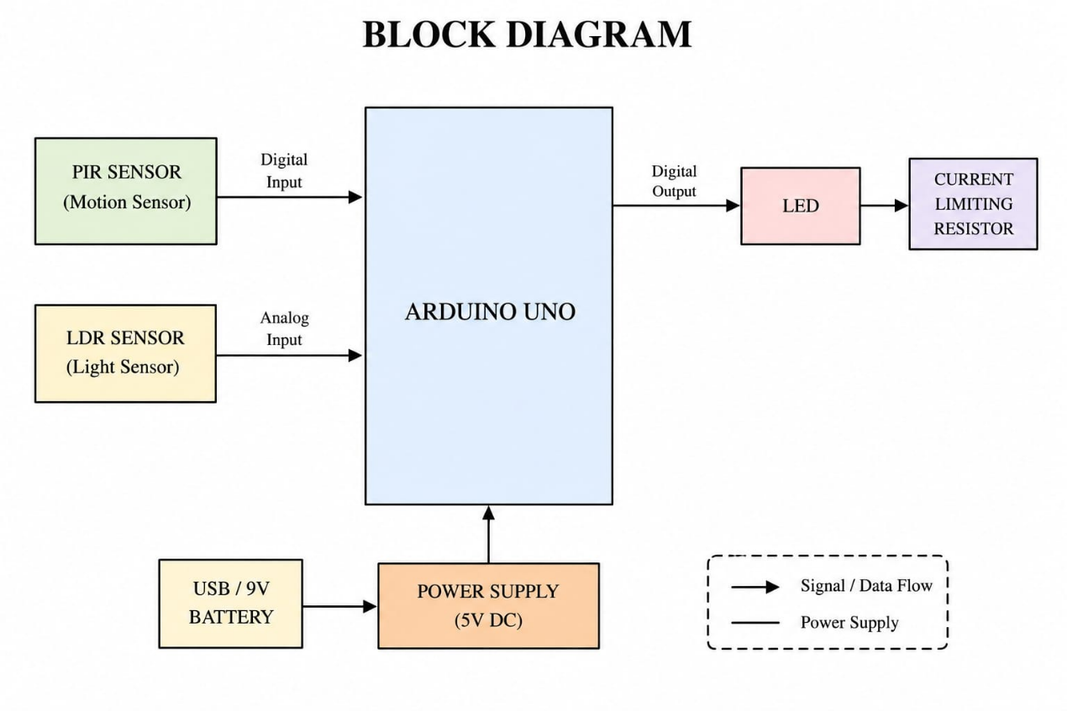

Figure 3.1: Block Diagram of Smart Street Light System

3.2 CIRCUIT DESCRIPTION
The circuit is built on a breadboard with Arduino Uno as the central processing unit. The LDR forms a voltage divider with a 10kΩ resistor connected to the 5V supply and GND. The midpoint of this voltage divider is connected to the analog pin A0 of Arduino. The PIR sensor, which operates at 5V, has its output pin connected to digital pin D2. The LED is connected to PWM-capable pin D9 through a 220Ω current-limiting resistor.

3.3 WORKING PRINCIPLE
Working Principle of the Smart Street Light System
The system is designed to provide automatic and energy-efficient street lighting using an Arduino Uno, an LDR (Light Dependent Resistor), a PIR motion sensor, and an LED. The Arduino continuously monitors ambient light intensity and human movement to control the brightness of the LED intelligently.

Daytime Operation
The LDR senses the surrounding light intensity and sends an analog voltage signal to the Arduino through the analog input pin. The Arduino converts this signal into a digital value ranging from 0 to 1023.
A threshold value of 700 is used to determine whether it is day or night.
When the LDR value is greater than 700:
- The environment is considered bright (daytime).
- The Arduino turns the LED completely OFF.
- This prevents unnecessary power consumption during daylight hours.

The decision condition is:
$$LDR Value>700$$
Thus, no street lighting operation occurs during the day.

Nighttime Operation
When the surrounding light intensity decreases, the LDR resistance increases, causing the analog reading to fall below the threshold value.
The nighttime condition is:
$$LDR Value<700$$
Under this condition, the Arduino activates the smart lighting mode and starts monitoring the PIR sensor.

Motion Detection Using PIR Sensor
The PIR (Passive Infrared) sensor detects infrared radiation emitted by moving human bodies or animals. The sensor output becomes HIGH whenever motion is detected within its sensing range.

Case 1: Motion Detected
If the PIR sensor output is HIGH:
- The Arduino interprets that a person or vehicle is nearby.
- The LED brightness is increased to maximum intensity using PWM.
- The PWM value is set to 255 for full brightness.
The PWM relation is:
$$PWM=255$$
This provides proper visibility and safety for pedestrians or vehicles during nighttime.

Case 2: No Motion Detected
If the PIR sensor output remains LOW:
- No movement is detected nearby.
- Instead of turning the light completely OFF, the LED glows dimly.
- A lower PWM value of 80 is applied.
Dim-light operation:
$$PWM=80$$
This approach:
- Conserves electrical energy,
- Reduces unnecessary power wastage,
- Maintains minimal illumination for safety and security.

CHAPTER 4
COMPONENTS DESCRIPTION

S.No. | Component | Quantity
1 | Arduino Uno R3 | 1
2 | PIR Sensor (HC-SR501) | 1
3 | LDR (Light Dependent Resistor) | 1
4 | LED (5mm, White) | 1
5 | Resistor 220Ω | 1
6 | Resistor 10kΩ | 1
7 | Breadboard | 1
8 | Connecting Wires | As required
Table 4.1: List of Components

4.1 ARDUINO UNO
The Arduino Uno is an open-source microcontroller board based on the ATmega328P. It features 14 digital I/O pins (6 of which support PWM output), 6 analog input pins, a 16 MHz ceramic resonator, a USB connection, a power jack, and a reset button. It operates at 5V and is programmed using the Arduino IDE. The PWM capability of pin D9 is utilized in this project to control LED brightness.

4.2 PIR SENSOR (HC-SR501)
The PIR (Passive Infrared) sensor detects infrared radiation emitted by humans and animals within its detection range. The HC-SR501 module has a detection range of up to 7 meters with a 120° cone angle. It operates at 5–20V DC and provides a digital HIGH output when motion is detected. The sensitivity and time delay can be adjusted using the onboard potentiometers.

4.3 LDR SENSOR
An LDR (Light Dependent Resistor), also known as a photoresistor, is a passive electronic component whose resistance decreases as the intensity of incident light increases. In this project, the LDR is connected in a voltage divider configuration with a 10kΩ resistor. During bright daylight, the LDR resistance is low, resulting in a high analog voltage at pin A0. During darkness, the resistance is high, resulting in a lower voltage at A0.

4.4 LED AND RESISTORS
A standard 5mm red LED is used as the street light indicator in the simulation. The LED is connected to pin D9 through a 220Ω current-limiting resistor to prevent damage from excessive current. The brightness of the LED is controlled using PWM (Pulse Width Modulation) with values ranging from 0 (OFF) to 255 (full brightness). A 10kΩ resistor is used in the LDR voltage divider network.

CHAPTER 5
SOFTWARE IMPLEMENTATION

5.1 ARDUINO IDE
The program for the Arduino Uno is written using the Arduino Integrated Development Environment (IDE). The code is written in embedded C language and compiled to generate a HEX file that is uploaded to the microcontroller. The key functions used are: pinMode() for configuring pin modes, analogRead() for reading the LDR value, digitalRead() for reading the PIR output, and analogWrite() for PWM-based LED brightness control.

5.2 PROGRAM CODE
int ldrPin = A0; // LDR connected to Analog pin A0
int pirPin = 2; // PIR sensor connected to Digital pin D2
int ledPin = 9; // LED connected to PWM pin D9
int ldrValue = 0;
int motionStatus = 0;
void setup()
{
pinMode(pirPin, INPUT);
pinMode(ledPin, OUTPUT);
Serial.begin(9600);
}
void loop()
{
ldrValue = analogRead(ldrPin); // Read LDR value (0-1023)
motionStatus = digitalRead(pirPin); // Read PIR status

Serial.print("LDR Value: ");
Serial.println(ldrValue);
if (ldrValue > 700) // Daytime condition
{
analogWrite(ledPin, 0); // LED OFF
}
else // Nighttime condition
{
if (motionStatus == HIGH) // Motion detected
{
analogWrite(ledPin, 255); // Full brightness
}
else // No motion
{
analogWrite(ledPin, 80); // Dim brightness
}
}
delay(100);
}

5.3 TINKERCAD SIMULATION
Tinkercad is a free, browser-based 3D design and circuit simulation tool developed by Autodesk. The circuit was assembled virtually on Tinkercad using the drag-and-drop interface. All components including Arduino Uno, breadboard, PIR sensor, LDR, LED, and resistors were available in the Tinkercad component library. The simulation was run for 4 minutes and 17 seconds to verify the correct operation of the system under different conditions. The Serial Monitor was used to observe the LDR analog values in real time during simulation.

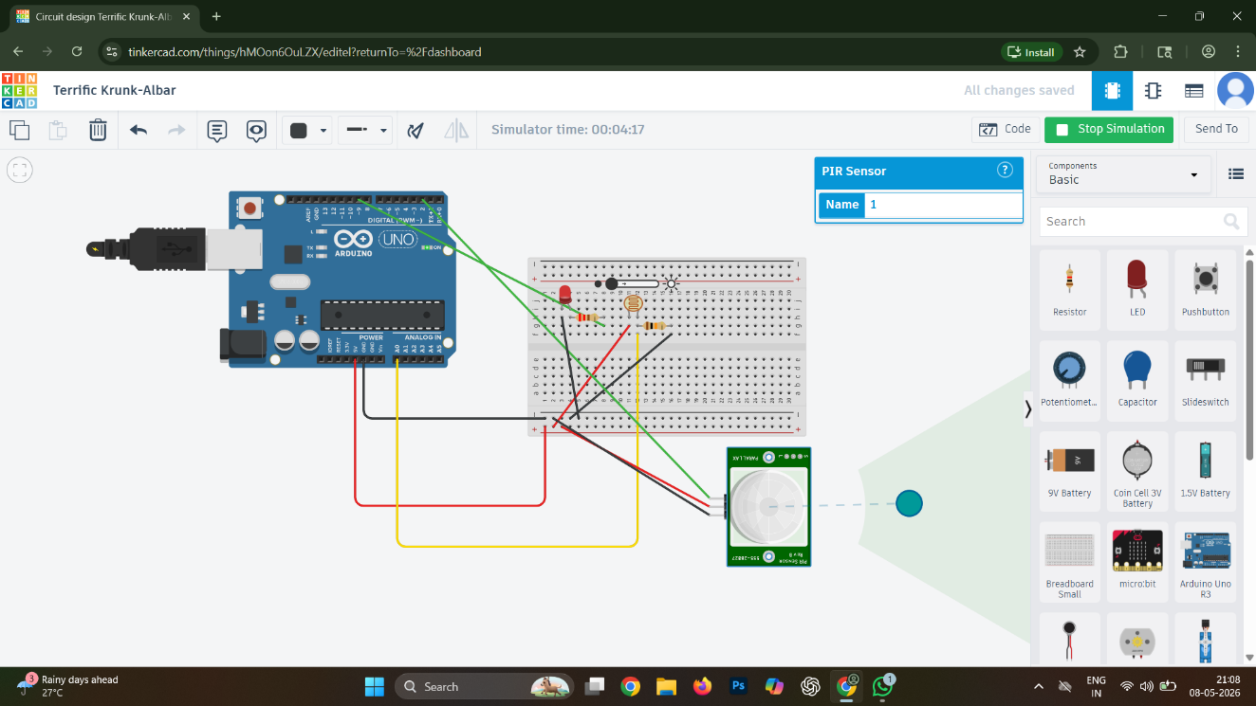
Figure 5.3: Tinkercad Simulation

5.4.HARDWARE IMPLEMENTATION
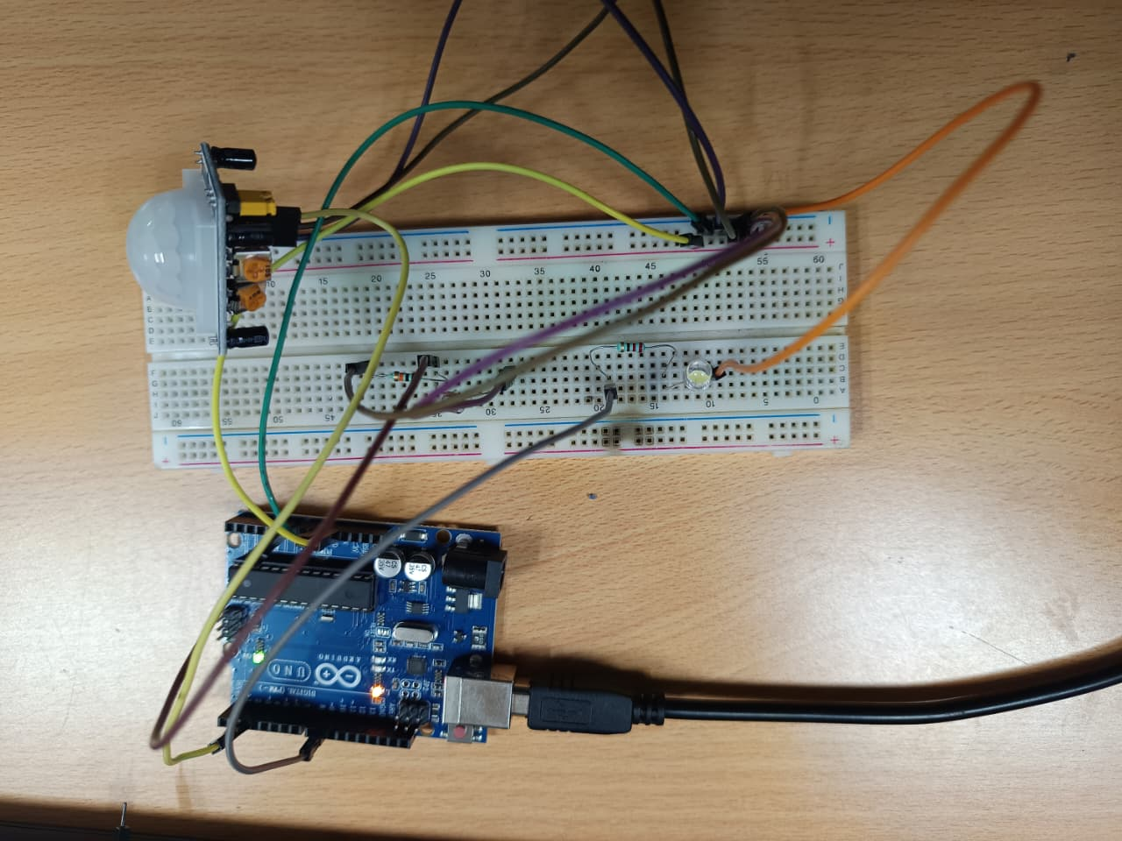
Figure 5.4: Circuit connection
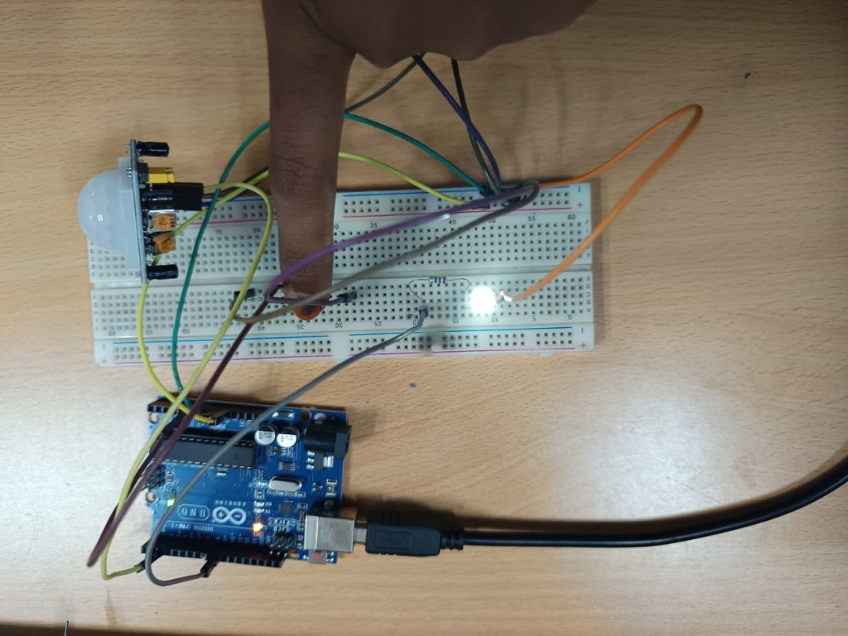
Figure 5.4: Hardware output
CHAPTER 6
RESULTS AND DISCUSSION
The simulation of the Smart Street Light System was successfully carried out in Tinkercad. The system was tested under three operating conditions, and the results are tabulated below.
S.No. | Condition | LDR Value | LED Output
1 | Daytime (Brightlight) | > 700 | OFF (PWM = 0)
2 | Night – No Motion | < 700 | DIM (PWM = 80)
3 | Night –MotionDetected | < 700 | FULL BRIGHT (PWM = 255)
Table 6.1: Simulation Results
The results confirm that the system correctly identifies daytime and nighttime conditions based on the LDR analog readings. During the Tinkercad simulation, the LDR slider was adjusted to simulate different light levels, and the LED responded accordingly. The PIR sensor trigger was activated manually to simulate motion detection, and the LED brightness switched from dim to full brightness instantaneously.
The PWM-based brightness control was verified by observing the voltage across the LED using the Tinkercad multimeter tool. The system demonstrated consistent and reliable performance throughout the simulation duration of over 4 minutes. These results validate the design and confirm that the proposed system is capable of achieving significant energy savings compared to conventional always-on street lighting systems.
CHAPTER 7
CONCLUSION AND FUTURE SCOPE
This project successfully demonstrated the design and simulation of a Smart Street Light System using Arduino Uno, PIR sensor, and LDR sensor. The system achieved automatic day/night detection using the LDR and motion-based adaptive brightness control using the PIR sensor and PWM technique. The Tinkercad simulation validated the correct operation of the system under all three operating conditions.
The proposed system offers a practical and cost-effective solution for energy-efficient street lighting. By automatically dimming the lights during low-traffic periods and fully illuminating them only when required, the system can contribute to substantial energy savings in urban and rural street lighting infrastructure.
7.1 FUTURE SCOPE
The following enhancements can be considered for future development of this project:
- Integration of solar panels for renewable energy-powered street lights.
- Implementation of GSM or IoT module for remote monitoring and fault detection.
- Replacement of LED with high-power LED strips for real-world deployment.
- Networking of multiple street light nodes for smart city grid management.
- Cloud-based data logging for energy consumption analysis and optimization.

APPENDICES
APPENDIX A – ARDUINO SOURCE CODE
int ldrPin = A0; // LDR connected to Analog pin A0
int pirPin = 2; // PIR sensor connected to Digital pin D2
int ledPin = 9; // LED connected to PWM pin D9

int ldrValue = 0;
int motionStatus = 0;

void setup()
{
pinMode(pirPin, INPUT);
pinMode(ledPin, OUTPUT);
Serial.begin(9600);
}

void loop()
{
ldrValue = analogRead(ldrPin); // Read LDR (0–1023)
motionStatus = digitalRead(pirPin); // Read PIR status

Serial.print("LDR Value: ");
Serial.println(ldrValue); APPENDIX B – PIN CONNECTION TABLE
if (ldrValue > 700) // Daytime condition
{
analogWrite(ledPin, 0); // LED OFF
}
else // Nighttime condition
{
if (motionStatus == HIGH) // Motion detected
{
analogWrite(ledPin, 255); // Full brightness
}
else // No motion
{
analogWrite(ledPin, 80); // Dim brightness
}
}
delay(100);
}

APPENDIX B – PIN CONNECTION TABLE

S.No. | Component | Arduino Pin | Connection Type
1 | LDR (midpoint) | A0 | Analog Input
2 | PIR Sensor OUT | D2 | Digital Input
3 | LED (via 220Ω) | D9 | PWM Output
4 | Breadboard + rail | 5V | Power Supply
5 | Breadboard – rail | GND | Ground

APPENDIX C – COMPONENT SPECIFICATIONS

S.No. | Component | Specification
1 | Arduino Uno | ATmega328P, 5V, 16 MHz
2 | PIR Sensor | HC-SR501, 5–20V, Range: 7m
3 | LDR | 5mm, Resistance: 1kΩ–1MΩ
4 | LED(White) | 5mm Red, Forward Voltage: 2V
5 | Resistor 1 | 220 Ω (current limiting)
6 | Resistor 2 | 10 kΩ (voltage divider)

APPENDIX D – PWM BRIGHTNESS LEVELS

Condition | PWM Value | Brightness
Daytime | 0 | OFF
Night – No Motion | 80 | Dim (31%)
Night – Motion Detected | 255 | Full (100%)
REFERENCES

- Kumar, R. and Singh, A. (2017) 'LDR Based Automatic Street Light Control System', International Journal of Innovative Research in Science, Engineering and Technology, Vol. 6, No. 4, pp. 6745–6751.

- Lim, T., Park, S. and Lee, J. (2015) 'Design and Implementation of PIR Sensor-Based Automatic Street Lighting System', Journal of Electrical Engineering and Technology, Vol. 10, No. 3, pp. 1152–1160.

- Popa, M., Popa, A.S. and Chiciudean, D. (2013) 'Smart Street Lighting Control System Based on Wireless Sensor Networks', Proceedings of the 13th International Conference on Optimization of Electrical and Electronic Equipment, pp. 1223–1228.

- Raghunath, P., Subrahmanyam, G.V. and Rani, T.S. (2019) 'Energy Efficient Street Lighting System Using Arduino and Sensors', International Journal of Recent Technology and Engineering, Vol. 8, No. 2, pp. 4523–4527.

- Arduino Official Documentation (2024) 'Arduino Uno Rev3 Datasheet', Available at: https://store.arduino.cc/products/arduino-uno-rev3

- Autodesk Tinkercad (2024) 'Circuit Simulation with Tinkercad', Available at: https://www.tinkercad.com

